WeatherPy Conclusions Ly Li

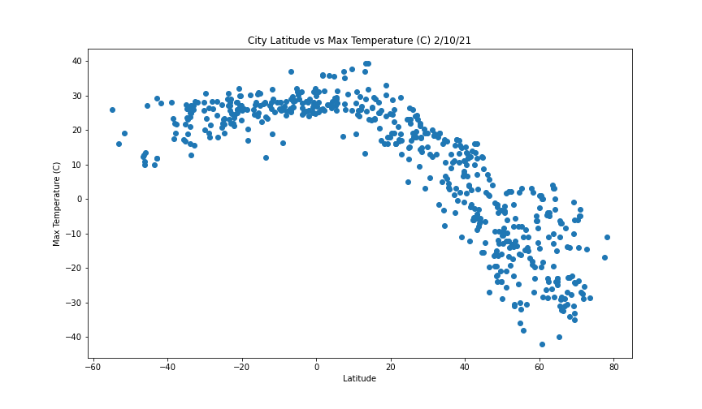 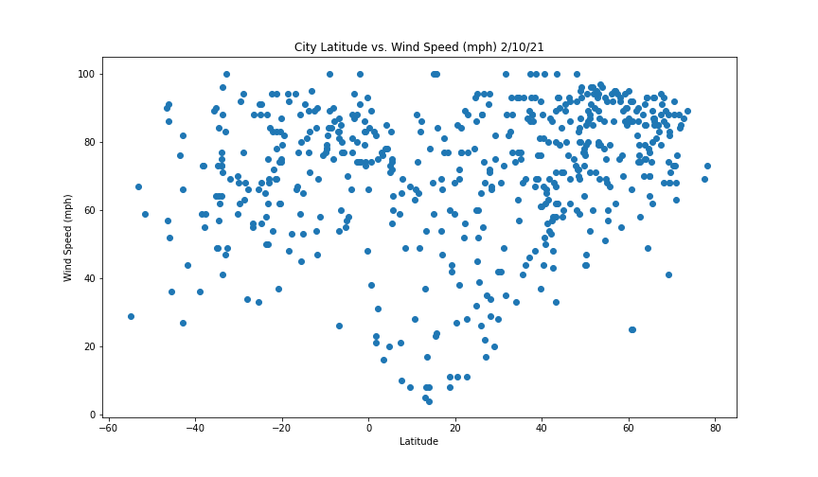

The further the city is from the equator (the father its latitude from 0), the colder it is (the lower its max temperature). The curve roughly resembles an upside-down parabolic “V” shape. It seems the Northern hemisphere get much colder than the Southern hemisphere cities at its extreme, but there are also fewer data points: this trend may be just because there are more cities in the extreme North than there are in the extreme South, geographically.

Meanwhile, wind speed & humidity tend to follow the opposite curve (right-side up “V” shape), where wind speeds are higher the further you get from the equator. However, the correlation is much less clear for wind speed & humidity than it was for temperature: because wind/humidity are determined by a variety of factors (such as ocean currents and how landlocked the city is), whereas temperature is determined mainly by location, as the graphs show.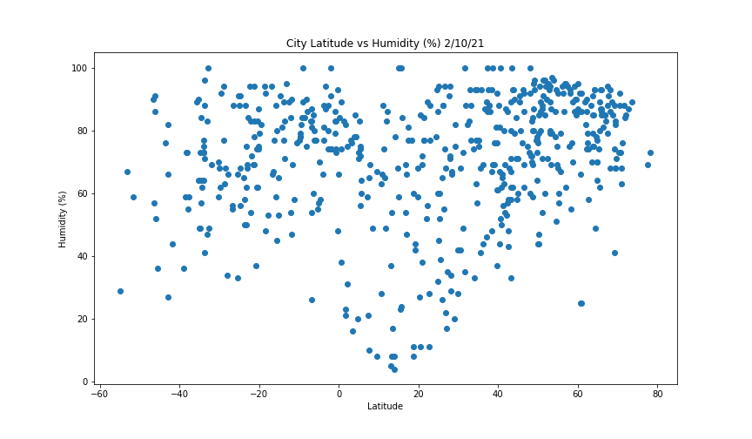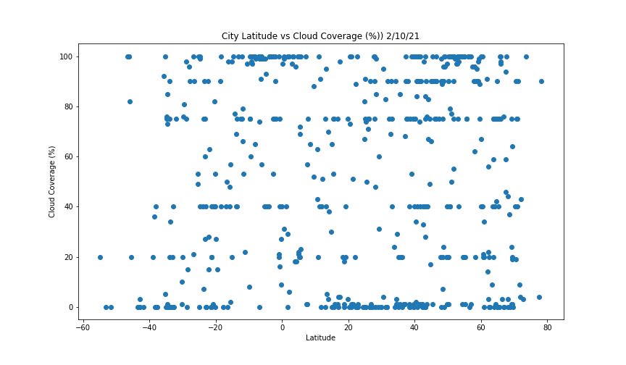

When are look at cloud coverage, there is virtually no discernible pattern based on latitude. This indicates to me that cloud coverage is the most complex weather trait we have investigated so far. Cloud coverage probably depends significantly on a combination of location, humidity, and wind, among other factors. I would be curious to see if we could find correlations in a pivot table with the above factors listed. Simpler traits are more highly correlated to 1 variable (such as location), whereas the more complex traits would require more complex pattern investigation, such as using a pivot table to investigate several factors simultaneously.

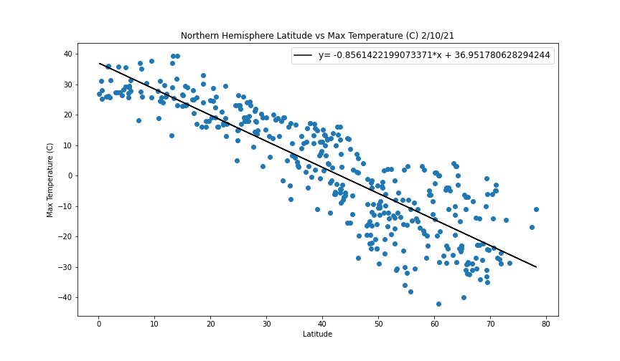

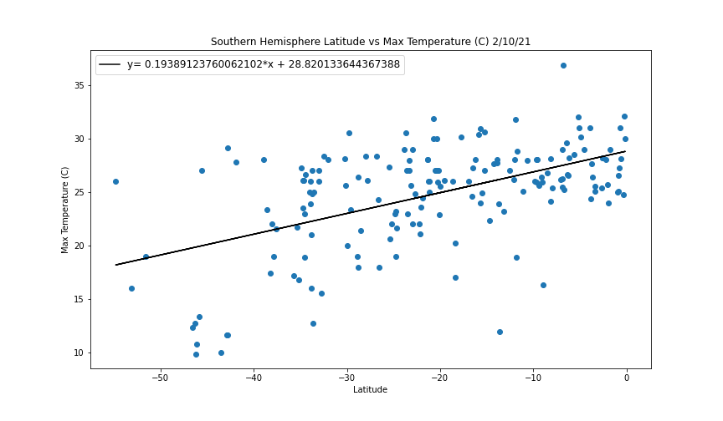

When we break down max temperature by hemisphere, we see clearly that there are far more cities in the Northern extreme of our globa ethan the Southern end. Both graphs show the approximate expected overall trend, which is the farther from the equator, the colder. However, the Northern cities show a much stronger (inverse) correlation (R= -0.87 for North vs R = 0.52 for South), which may be because the Northern hemisphere is more landlocked than the Southern hemisphere. It seems that location is the primary factor in determining temperature, especially for landlocked cities-but cities that are closer to the ocean coast may experience fluctuations from the weather of the ocean that spills over to the weather on land

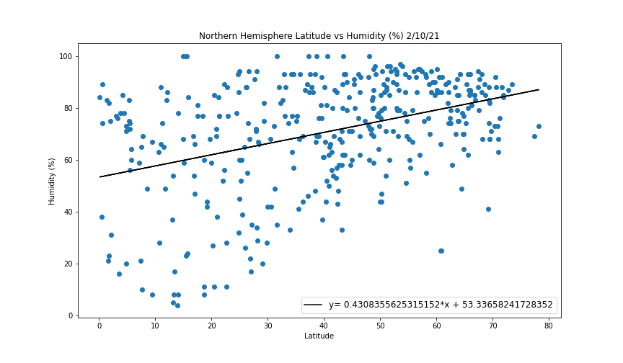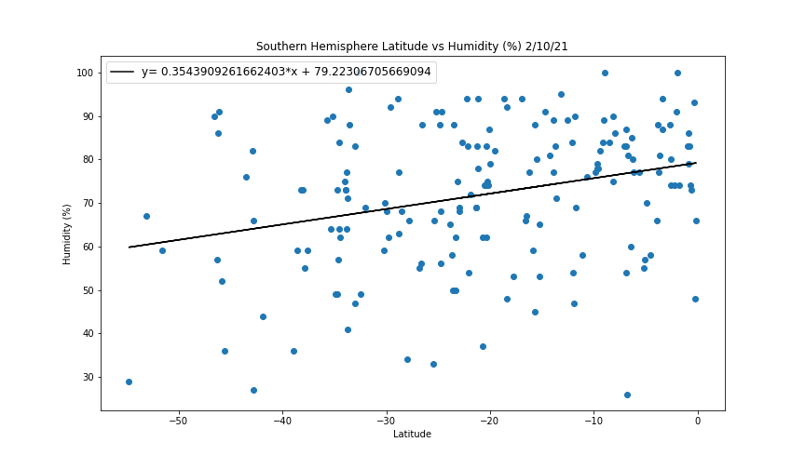

When we look at humidity by hemisphere, we see that the 2 hemispheres show opposite trends-in the North, the further from the equator, the more humid; in the South, the closer to the equator, the more humid. This makes sense because the Southern hemisphere has less land and more water than the North, also evidenced by how many fewer data points there are for Southern hemisphere cities, and supports my theory above for why latitude/temperature correlation is stronger in the North than the South due to more landlocked cities in the North vs more coastline cities in the South that receive a greater influence from ocean weather and currents.

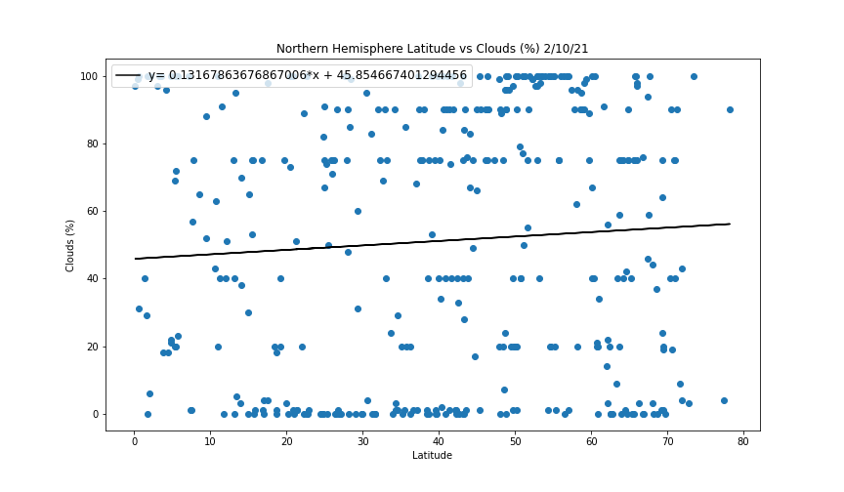

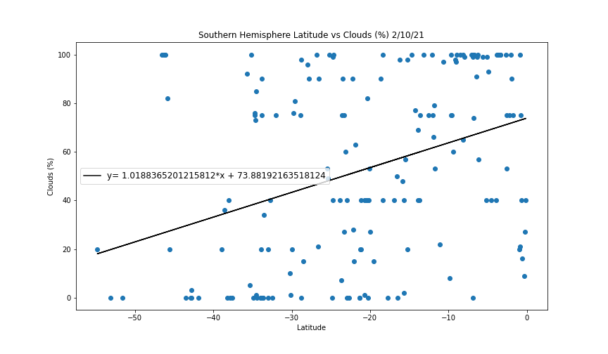

There is virtually no correlation (R = 0.067) between location and cloud coverage in te Northern hemisphere, while there is a modest correlation between location and cloud coverage in the Southern hemisphere (R = 0.36) -the closer to the equator the city is to the equator, the more cloud coverage.

Wind speed correlation in the North and South are both pretty weak and to the same degree (R=0.36 for North, R =-0.23 for South). The range of wind speeds are similar between the hemispheres, although generally, average winds seem to be a little higher in the South than in the North.

